Nurse Anesthesia Program Supplemental Handbook (MSN)

Table of Contents
Program Overview 3
Purpose of the Nurse Anesthesia Supplemental Handbook 3
Program Mission, Philosophy, Strategies, and Accreditation 3
Program Description and Trajectory 4
Transfer Credits 4
Academic Standards 4
Program Time Commitment 4
Faculty Advisors 5
Annual Progress Reports 5
Course Questions/Issues Chain of Command 5
When a student encounters an issue or problem in a course, it is expected that the student contacts and seeks resolution with the course faculty first. Please follow the faculty’s preferred method of contact according to the course syllabus. A chain of command is available to assist students in determining when to involve the program director or Associate Dean for Academic Affairs (ADAA) in Appendix E. 5
Grading Scale 5
Progression in the Program 6
Dismissal 6
Reinstatement Process 6
Student Grievance and Hearing Procedures 7
Composition of the College of Nursing Hearing Board: 7
Leave of Absence 7
Reinstatement After Lapse in Enrollment 8
Program Extension 8
Program Concentration Change Policy 8
Graduation Criteria 9
Program Policies and Procedures 9
Compliance Requirements 9
Responsibility Conduct of Research, Scholarship, and Creative Activities (RCRSA): 9
Program Attendance 9
Attendance for on-campus classes 10
Time Off for Other NAP Related Educational Activities 10
Employment Policy 10
Communications Policy 10
AANA and MANA Meeting Attendance Policy 11
Self-Evaluation Exam 11
Inclement Weather Policy 11
Clinical Education Policies and Procedures 12
Attendance for clinical 12
Rescheduling or Altering Clinical Days 12
Dress Code 12
Clinical Practicum Rotations and Travel Requirements 13
Clinical Supervision 13
Clinical Supervision Ratios 13
On-Call Experiences 14
Affiliate Clinical Site Policies and Procedures 14
Dress Code 14
Management Plan and Clinical Evaluation Instruments 14
Nurse Anesthesia Student Tracking System™ (NAST) 15
Prior to a Clinical Rotation - Check List 15
Daily Clinical Rotation - Check List 15
End of Rotation - Check List 16
Student Time Logs 16
Malpractice Insurance 16
Student and Program Evaluation 16
Appendix A 17
Appendix B 18
Appendix C 22
Appendix D 30
Appendix E 31
Appendix F 33
Appendix G 34
Appendix H 36

Program Overview

Purpose of the Nurse Anesthesia Supplemental Handbook
The DNP Nurse Anesthesia Supplemental Handbook contains information, policies and procedures specific to the Michigan State University (MSU) Nurse Anesthesia Program (NAP). Nurse anesthesia (NA) students enrolled in the NAP are also subject to the policies and procedures contained within the College of Nursing Core Handbook and the Michigan State University Spartan Life Handbook. An electronic copy of the NA Supplemental Handbook (SH) is located on the College of Nursing (CON) website under “Student Resources”.

The policies and procedures in the SH may be subject to change. If change occurs, students will be notified via MSU e-mail. Please direct questions specific to content within the SH to the NAP Director.

Program Mission, Philosophy, Strategies, and Accreditation
Mission
In concert with the MSU and CON mission statements, the NAP is committed to the education and preparation of nurse leaders capable of delivering safe, competent anesthesia services in an ever-changing health care environment.

Philosophy
The practice of nurse anesthesia rests upon a sound foundation of arts and sciences that prepares graduates to excel in a rapidly changing, diverse, and technologically advanced society. Active participation in MSU’s Land Grant Mission provides opportunity for a student’s personal and professional growth. The program’s teaching and learning activities are evidence-based, patient-centered, and driven by projected changes in anesthesia practice. The NAP faculty serve as students’ guides, mentors, and role models.

Strategies
The NAP will distinguish itself through differentiated strategies that include:
S tudent-centered, diverse foci
P ractice/learning opportunities that reflect the ever-changing needs of our patient
communities
A ttitudes that reflect scholarship and caring
R etention initiatives
T eaching excellence
Y ear-round accessibility

Accreditation
The MSU College of Nursing’s programs are accredited by the Commission on Collegiate Nursing Education (CCNE). The NAP is accredited by the Council on Accreditation of Nurse Anesthesia Educational Programs (COA), 222 South Prospect Avenue, Park Ridge, Illinois 60060; (847) 692-7050 – a specialized accrediting body recognized by the Council for Higher Education Accreditation and the United States Department of Education. The NAP’s next accreditation review by the COA is scheduled for October 2023.

Program Description and Trajectory

The MSN NAP is a rigorous, 36-month, full-time program that exceeds the clinical and didactic requirements set by the COA (see Appendix A for minimum didactic requirements and Appendix B for minimum clinical requirements) and the American Association of Colleges of Nursing’s Doctoral Essentials. The nurse anesthesia curriculum combines didactic and clinical experiences that emphasize critical thinking, scientific inquiry, and effective interpersonal, interprofessional, and psychomotor skills (see Appendix C for curriculum crosswalk). The curriculum is sequenced to build on previously acquired knowledge and skills (see Appendix D for the program trajectory). Content is delivered through face-to-face, online, simulated, and clinical instruction.

As part of the graduate school requirement, MSN NA students will complete a scholarly project. The completion of this project is embedded and described in NUR 895 and 896.

Transfer Credits
Up to 25% of graduate coursework (excluding DNP project credits) may be transferred into the DNP program from an accredited program. The transfer of course credits from other institutions may be completed through the following procedure:
When possible, obtain written permission from the faculty advisor and program director before enrolling in a course at another university.
- Send a copy of this written permission to: College of Nursing Student Affairs,
Bott Building for Nursing Education and Research.
- When the course is completed at another institution, request that official transcript of the grade(s) be sent to:
- College of Nursing, Office of Student Affairs, Bott Building for Nursing Education
and Research, 1355 Bogue Street, Room C120, East Lansing, Michigan 48824-
1317.
- Students must submit the course syllabi and an official transcript for review when
requesting credit for transfer courses completed without prior approval.
- Materials should be submitted to the College of Nursing, Office of Student
Affairs, Bott Building for Nursing Education and Research, 1355 Bogue Street,
Room C120, East Lansing, Michigan 48824-1317.

Academic Standards

Program Time Commitment
The nurse anesthesia student must be able to devote the time necessary to be successful in the NAP. NA students in programs across the United States report an average commitment of 50-60 hours per week. Additional time is required for study, pre/post-operative visits, formulating anesthesia management plans, and completion of the doctoral project.

Faculty Advisors
All students in the NAP will be assigned a NA faculty advisor. The Michigan State University Graduate School dictates the duties of CON faculty advisors in the MSN and DNP degree programs. Faculty advisors are expected to:
- Be a mentor for their advisees
- Demonstrate professional role modeling
- Serve as the DNP project faculty mentor
- Develop a plan of study in collaboration with the program director

Faculty advising provides an opportunity for mentoring and professional guidance in a collegial and safe environment. Socialization and mentoring are best achieved in a mutually responsive relationship. Students are expected to:
- Make regular contact with their faculty advisor, at least once per semester
- Respond to all faculty advisor communication within a reasonable timeframe
- Communicate any changes in circumstances that may impede ability to complete
coursework as required
All university communication between student and faculty advisor must be done using MSU email (@msu.edu). Students may initiate a change of advisor assignment by contacting the Office of Student Affairs. The CON assigns the faculty advisor after consultation with the appropriate parties.

Annual Progress Reports
All students complete an annual progress report in collaboration with their faculty advisor, in fulfillment of the MSU’s Graduate School requirements. The annual progress report is a part of the electronic student academic file and needs to be completed and submitted to the Office of Student Affairs by April 1st.

Course Questions/Issues Chain of Command

When a student encounters an issue or problem in a course, it is expected that the student contacts and seeks resolution with the course faculty first. Please follow the faculty’s preferred method of contact according to the course syllabus. A chain of command is available to assist students in determining when to involve the program director or Associate Dean for Academic Affairs (ADAA) in Appendix E.

Grading Scale
The standard College of Nursing graduate program grading scale will be used for all NUR courses:
% | GRADE
100 - 94 | 4.0
93-87 | 3.5
86 – 80 | 3.0  (Minimum passing grade)
79 – 75 | 2.5
74 – 70 | 2.0
66 – 65 | 1.5
64 – 60 | 1.0
Below 60 | 0.0

Progression in the Program
Progression in the NAP requires:
1. A 3.0 cumulative GPA, and
2. A minimum of a 3.0 or passing grade in each required (both NUR and non-NUR
numbered) course)

If a grade below a 3.0 is attained, the student will be dismissed from the program.

Dismissal
NA students may be dismissed from the NAP for deficiencies in didactic and clinical course work and noncompliance with MSU, CON, NAP, and affiliate clinical sites’ policies and procedures.

Reinstatement Process
Any student seeking reinstatement to the College of Nursing must write a letter to the Associate Dean for Academic Affairs (ADAA) which includes the following:
- Explanation of the student’s withdrawal or dismissal
- Reason for seeking reinstatement to the student’s respective program director
- For students who have withdrawn from their program: an explanation of how the
circumstances that led to their withdrawal have changed
- For students who have been dismissed from their program: a detailed plan for success in
their program moving forward, including recommendations from their academic
advisor.
- Which semester the student wishes to return

Upon receipt of request for reinstatement, the ADAA or designee will respond to the student through MSU email to inform them that their request has been received and is being processed.

The ADAA or designee will contact the course faculty, program director, and faculty advisor (if applicable) to receive input on the student’s potential for success and recommendation regarding reinstatement. Upon reaching a decision in collaboration with program faculty, the ADAA or designee will inform the student of their reinstatement decision. All final reinstatement decisions are dependent on course space availability.

Student Grievance and Hearing Procedures
The Academic Freedom for Students at Michigan State University (AFR) and the Graduate Student Rights and Responsibilities (GSRR) documents establish the rights and responsibilities of MSU students and prescribe procedures for resolving allegations of violations of those rights through formal grievance hearings. In accordance with the AFR and the GSRR, the College of Nursing has established the following College Hearing Board procedures for adjudicating academic grievances and complaints.

AFR Article 6 - Academic Hearing Board Structures:
http://splife.studentlife.msu.edu/student-rights-and-responsibilities-at-michigan-state-university/article-6-academic-hearing-board-structures

AFR Article 7 - Adjudication of Academic Cases:
http://splife.studentlife.msu.edu/student-rights-and-responsibilities-at-michigan-state-university/article-7-adjudication-of-academic-cases

GSRR Article 5 - Adjudication of Cases Involving Graduate Student Rights and Responsibilities:
http://splife.studentlife.msu.edu/graduate-student-rights-and-responsibilities/article-5-adjudication-of-cases-involving-graduate-student-rights-and-responsibilities

Composition of the College of Nursing Hearing Board:
- The college shall constitute a College Hearing Board pool no later than the end of the
tenth week of the spring semester.
- For hearings involving advanced practice students, the College Hearing Board shall
include the Chair of the Advanced Practice Program Committee (APPC) or a designee,
two faculty, and two designated students. Faculty alternates to the College Hearing
Board will be selected from APRN faculty members; student alternates will be selected
according to the procedures established by the Student Advisory Council. If needed,
additional alternates will be appointed by the APPC. (See AFR 6.II.B, C, and D.)
- The chair of the College Hearing Board shall be a hearing board member with faculty
rank. All members of the College Hearing Board shall have a vote, except the chair, who
shall vote only in the event of a tie. (See AFR 6.II.C.)
- The college will train hearing board members about these procedures and the
applicable sections of the AFR. (See AFR 7.IV.C.)

Leave of Absence
Students who have completed courses in the program may submit a request for a leave of absence for no more than one year. A new plan of study should be developed in collaboration with the faculty advisor and program director. The decision to approve/disapprove leave requests is at the discretion of the ADAA.

Students who stop advancing academically for more than three semesters without an approved and current plan of study are subject to dismissal from the program. Reinstatement in the program is based on compliance with the plan of study and availability of space in the required courses and anesthesia cohort.

Reinstatement After Lapse in Enrollment
Graduate students who have stepped away for three academic semesters or more must request readmission in a letter to the ADAA by February 1 for Fall semester, August 1 for Spring semester, or December 1 for Summer semester addressing the following:
- Reason for seeking readmission
- Reason for withdrawal/dismissal
- How his/her situation has changed in the interim
- Response to any recommendations that may have been made at the time of withdrawal/dismissal
- Which semester the student wishes to return
Requests for reinstatement should be sent to the Office of Student Affairs and ADAA. The final decision for readmission will be determined by the dean and ADAA who will notify the student in writing of the final decision.
Students who have failed to enroll for more than one academic year must also
- Complete and submit a University Application for Readmission (available online at www.reg.msu.edu, click on Readmissions) at least two months prior to the first day of registration.
- Complete and submit necessary compliance documentation including completion of a new background check and drug screen.

Program Extension
Students enrolled in the NAP are expected to complete all graduation requirements in 36 months. At the discretion of the ADAA and NAP Director, a student’s course of study may be extended beyond the 36 months if a student, who is in good academic standing, does not complete the graduation criteria, academic coursework, or required record entries in the Nurse Anesthesia Student Tracking SystemTM (NAST).

Program Concentration Change Policy
This policy applies to students currently enrolled in the CNS, NP, or NA concentration who wish to change to another concentration. Students wishing to change to the NA concentration need to follow the complete admissions process outlined on the MSU College of Nursing website.
Students considering a concentration change must be in good standing in their current program, maintaining an 80% GPA or higher in every course.
The following process will be followed:
- The student will arrange a meeting with their faculty advisor and current program
director to discuss their interest in changing their current program concentration.
- The student will compose an essay documenting their rationale for why they would like
to make a program change.
- The student will submit their essay to the program director of the concentration
they would like to change to and
- The graduate advisor in the Office of Student Affairs
- The student will complete an interview with the program director of the desired
concentration.
- The request to change concentrations will be submitted by the program director of the
desired concentration for review by the Advanced Practice Program Committee (APPC)
for final approval. All decisions made by the APPC are final.

Graduation Criteria

A student will be eligible to take the Nation Certification Examination (NCE) administered by the National Board of Certification and Recertification for Nurse Anesthetists (NBCRNA) only after they have met the NAP End of Program Outcomes (Appendix F), the COA Graduate Standards (Appendix G), and minimum case requirements (Appendix B)

Program Policies and Procedures

Compliance Requirements
In addition to the compliance requirements listed in the CON Core Handbook, nurse anesthesia students must possess a current Advanced Cardiac Life Support (ACLS) and Pediatric Advanced Life Support (PALS) certification. Any student who is out of compliance with the CON and NAP compliance policies will be unenrolled from his/her classes and removed from clinical.

Responsibility Conduct of Research, Scholarship, and Creative Activities (RCRSA):
Michigan State University requires that all graduate students be trained in the RCRSA basic educational requirements. The CON’s plan to meet the RCRSA requirements can be found in Appendix H. This plan includes completion of the Collaborative Institutional Training Initiative (CITI) training modules and a minimum of six hours of discussion-based training. In accordance with MSU policy, all RCRSA education requirements are to be completed by the end of the spring semester of year two. More information can be found at: https://grad.msu.edu/researchintegrity
- CITI Training Modules available at: https://ora.msu.edu/train/
- Human Research Protection and IRB Certification available
at: https://hrpp.msu.edu/training/index.html

Program Attendance
Students begin the program on the opening day of summer semester according to the MSU academic calendar and are enrolled for seven semesters (28 months) on a full-time basis. During the first two semesters of the program (spring, summer), time off occurs in accordance with the MSU academic calendar.

During the final five semesters, students will be continuously enrolled in clinical courses – including attending clinical between academic semesters – except for holiday time off in accordance with the academic calendar.

MSU has a policy permitting students to observe those holidays set aside for their chosen religious faith. More information can be found at https://inclusion.msu.edu/hiring/religious-observance-holidays.html.

Attendance for on-campus classes
Attendance for on-campus courses is mandatory. A student who is unable to attend an on-campus class will:
- Notify the course faculty before the start of the class (see course syllabus for the faculty’s preferred method of contact)
- Be responsible for acquisition of missed course content
Note: In the event of an emergency in transit to class, notify the course faculty by any means possible (text, call, notify a cohort member) when feasible.

Time Off for Other NAP Related Educational Activities
Students may request time off to attend other University or NAP-related educational
events with approval from the Program Director or Assistant Program Director. Requests for time off should be made through the MSU e-mail system at least 30 days prior to the scheduled event.

Employment Policy
NA students who engage in outside employment are encouraged to keep NAP time commitment factors in mind when scheduling work as a Registered Nurse (RN). Nurse anesthesia students are required to have at least eight (8) hours off between work as an RN and class or NA clinical shifts.

Under no circumstances may a NA student seek employment as a Nurse Anesthetist by title or function before successful completion of the program. This practice is prohibited not only by program policy but by law.

Communications Policy
All Nurse Anesthesia Students are required to check Desire2learn (D2L), MSU’s official course management software, and MSU e-mail daily (except during authorized time off) and follow directives in the messages. Correspondence sent through personal e-mail outside of the MSU e-mail system will not be answered.

AANA and MANA Meeting Attendance Policy
Students are required to attend one MANA state meeting and at least one AANA-sponsored meeting (Mid-Year Assembly, Annual Congress, Assembly of Didactic and Clinical Educators) while in the program. Requests for time to attend these events are to be submitted by e-mail to the program director for approval.

Students are also expected to attend MANAS meetings and participate in additional educational, community, or political opportunities. Requests for time to attend these events are to be submitted by e-mail to the program director for approval.

Self-Evaluation Exam
NA Students will purchase and complete the NBCRNA Self Evaluation Exam (SEE) twice during the program.
- The first exam will be taken in April-May of year two. Students are required to score a 400 or better in the following categories: Basic Sciences, Equipment, Instrumentation, and Technology & Basic Principles of Anesthesia and a 380 or better in the Advance Principles of Anesthesia category.
- The second exam will be taken in December of year three. Students are required to score a 420 or better in all exam categories.
- Students who do not meet these benchmarks will participate in a remediation process that includes content review and internal exams.

Inclement Weather Policy
The Inclement Weather Policy is located in the Core CON Handbook. The following guidelines will aid in the student and NAP’s decision-making process:

- In the event the university closes prior to the start of the class or clinical, students should remain home. Students will not be required to make up the clinical shift.

- In the event the university closes during a didactic class, students will be sent home. If the university closes during a clinical shift, students will consult with the course faculty and clinical site coordinator to determine if it is safe for the student to remain at the clinical site and finish the case or shift. Shortened clinical days will not be rescheduled.

- In the event the university is open, but a clinical facility is closed due to weather or other conditions, the student is not required to report to the facility nor any other open clinical facility. The student is required to notify the clinical course faculty who, in collaboration with the clinical site coordinator, will reschedule the missed clinical shift.

- In the event the university is open and a clinical facility is open but not operating an elective surgical schedule, the student should contact the clinical site coordinator to determine if he or she should report to the clinical site. The student is required to notify the clinical course faculty if they have been advised to stay home or leave the clinical site early. If the student is dismissed from the clinical site, the clinical day will not be rescheduled. If the student remains home, the course faculty, in collaboration with the clinical site coordinator, will reschedule the clinical shift.

In the event the university and the clinical facility are open during inclement weather, students should use their best judgment in ensuring their personal safety. Notify the clinical course faculty if a personal decision is made to not attend clinical. Follow the clinical site’s call-in procedure. These days will be rescheduled by the course faculty in collaboration with the clinical site coordinator.

Clinical Education Policies and Procedures

Attendance for clinical
Attendance in clinical is mandatory. A student who is unable to attend clinical due to
illness or a personal reason will:
- Notify the clinical course faculty by e-mail when absent from the clinical site prior to the start of the assigned clinical shift.
  - Follow the clinical site’s call-in procedure
  - Provide the clinical course faculty with an excuse from a medical provider when more than two consecutive clinical shifts have been missed

Rescheduling or Altering Clinical Days
Clinical site coordinators may not reschedule clinical make-up days. Instead, the clinical course faculty and the affiliate clinical site’s coordinator will collectively determine when the student will make up the missed clinical day(s).

Under no circumstances may a student alter the distributed clinical schedule or schedule clinical make-up time without the approval of the clinical course faculty. Requests for changes in the clinical schedule must be generated through MSU e-mail and approved by the clinical course faculty.

If a student wishes to extend their clinical shift more than 2 hours beyond the assigned time, the student should notify the course faculty. This can be done via e-mail, phone call, or text.

Dress Code
NA students are expected to dress consistent with the professional image of a registered nurse in an advanced practice graduate program while at the university or in the clinical setting. Proper attire must be worn in any situation that involves patient contact of any type. Students are responsible for knowing the dress regulations for each clinical facility and follow their policies and procedures. MSU- or facility-issued identification badges must always be worn while in the hospital/clinic setting. Failure to display proper identification is a serious offense. Students shall follow the clinical site’s policy on wearing jewelry, artificial fingernails, facial hair, body art, and personal scrub attire.

Clinical Practicum Rotations and Travel Requirements
In order to optimize the time spent during the clinical practicum, the nurse anesthesia student must actively seek learning experiences and function in a self-directed manner to achieve the knowledge, skills, and abilities to practice as a CRNA. The program will consider geographical proximity to the student’s home residence when developing the clinical schedule. However, students will be required to travel to clinical sites to obtain required clinical experiences. Students are responsible for the expenses incurred for clinical travel and lodging.

The following list indicates current clinical affiliate sites:
- Ascension St John Hospital, (Moross) Detroit Michigan
- McLaren Greater Lansing, Lansing, Michigan
- St. John Macomb-Oakland Hospital, Macomb Center, Warren, Michigan
- Ascension Providence Hospital, Southfield, Michigan
- Ascension Providence Hospital – Novi Campus, Novi, Michigan
- Henry Ford Allegiance Health, Jackson, Michigan
- Henry Ford Health System, Detroit, Michigan
- Sparrow Medical Center, Lansing, Michigan
- Mercy Health St Mary’s Campus, Grand Rapids, Michigan
- Beaumont – Trenton, Trenton, Michigan
- Gerber Memorial Hospital, Fremont, Michigan
- Bronson Hospital, Kalamazoo, Michigan
- Hillsdale Community Hospital, Hillsdale, Michigan
- ProMedica Coldwater Regional Hospital, Coldwater, Michigan
- Owasso Memorial Hospital, Owasso, Michigan

Other clinical sites may be added to meet the needs of the program.

Clinical Supervision
Supervision at clinical sites is limited to CRNAs and anesthesiologists who are institutionally credentialed to practice and immediately available for consultation. Clinical supervision in non-anesthetizing areas is restricted to experts who are authorized to assume responsibility for the student.

Clinical Supervision Ratios
Student to clinical instructor ratios are limited to a 1:1 ratio during the student’s junior year. At the discretion of the clinical instructor and in accordance with the clinical site’s policies, students in their second semester of clinical practicum may be left alone. The clinical instructor must be readily available to the student at all times.

The student to instructor ratio may be increased to 2:1 during a student’s senior year if both students demonstrate competency in safely managing an anesthetic, the complexity of the anesthetic and surgical procedure is appropriate for the student’s skill level, and the supervising CRNA or anesthesiologist is immediately available. At no time may the number of students directly supervised by an individual clinical instructor exceed 2:1. At no time may the NA student be used to augment anesthesia staffing due to anesthesia provider shortages.

On-Call Experiences
On-call is defined as a planned clinical experience outside the normal operating hours of the clinical facility. Call experiences in the NAP include:
- Hours that fall between 5pm – 7am
- Weekend shifts

Students may be assigned to a 24-hour call experience. At no time may a student provide direct patient care for a period longer than 16 continuous hours.
- Long periods of wakefulness can lead to detrimental decisions in patient care judgment. If a student is called in during an on-call shift, adequate time should be afforded to rest between the next clinical shift. When there is potential conflict between the call experience and the next morning’s scheduled surgery, the supervising anesthesia provider will determine which experience is more beneficial to the student and provide adequate time off.
- Students may contact the program director for direction or concerns if conflict between on-call and scheduled shifts occur.

When a student is “called in” during an on-call shift, there must be a qualified nurse anesthetist or anesthesiologist present on site and immediately available to the student. At no time may a student initiate anesthetic care without supervision.

Affiliate Clinical Site Policies and Procedures
Students rotating through an affiliate clinical site must complete the facility’s on-boarding processes and follow the policies and procedures of the institution and department. Failure to follow the clinical site’s policies and procedures may result in dismissal.

Dress Code
NA students are expected to dress consistent with the professional image of a registered nurse in an advanced practice graduate program while at the university or in the clinical setting. Proper attire must be worn in any situation that involves patient contact of any type. Students are responsible for knowing the dress regulations for each clinical facility and follow their policies and procedures. MSU- or facility-issued identification badges must always be worn while in the hospital/clinic setting. Failure to display proper identification is a serious offense. Students shall follow the clinical site’s policy on wearing jewelry, artificial fingernails, facial hair, body art, and personal scrub attire.

Management Plan and Clinical Evaluation Instruments
The Anesthesia Management Plan will be used as a guide to formulate an anesthesia plan of care for patients to whom students are assigned. The Anesthesia Management Plan will be discussed with the clinical preceptor prior to the beginning of each case. Students are expected to come to clinical prepared to discuss their proposed plans of care for each assigned patient.

The Clinical Evaluation Instrument will be used to assess the progression of each student during the practicum experiences. Clinical courses are graded as either Pass or No Pass. In order to pass the course, the student must have met all of the clinical course objectives and the critical elements identified on the Clinical Evaluation Instrument at the completion of the semester.

Nurse Anesthesia Student Tracking System™ (NAST)
The NA Program uses a web-based clinical student tracking system developed and maintained by the Typhon Group. The NAST serves two purposes. First, it documents student progress toward completing the required clinical experiences, end of program outcomes, and COA graduate standards. Second, it assists the faculty and student in selecting the most appropriate clinical experiences.
- Students will be provided an orientation to the NAST prior to clinical emersion.
- Clinical experiences should be entered and recorded in the NAST within 72 hours.
- The COA Guidelines for Counting Clinical Experiences provides guidance on how to interpret clinical experiences.
- Questions regarding data entry should be directed to the program director or assistant program director
- Students should check the accuracy of the personal information and clinical experiences monthly

Prior to a Clinical Rotation - Check List
- Complete clinical site on-boarding documents
- Review the clinical site’s policies, procedures, parking, and dress code information
- Initiate contact with the clinical coordinator at least 7 days before the rotation begins
  - If there is no response from the clinical coordinator for 48 hours after contact, notify the course faculty
- Obtain clinical badge, parking, department access codes, and medication codes (if required)

Daily Clinical Rotation - Check List
- At beginning of the day, provide the clinical instructor with Anesthesia Management Plan and Clinical Evaluation Instrument
- Pre-brief each case
- De-brief each case
- Complete the student self-evaluation and goals section of the Clinical Evaluation Instrument (required)
- Enter clinical experiences into NAST
- Return completed evaluations to the assistant program director

End of Rotation - Check List
- Thank clinical coordinator and instructors
- Return hospital property (identification badges, parking)
- Complete an end-of-rotation site evaluation located in NAST

Student Time Logs
Intermittently during the program, students may be required to complete time logs documenting the number of hours they spend in didactic and clinical activities. This information will be used to monitor program demands on student time.

Malpractice Insurance
Michigan State University provides malpractice insurance for students enrolled in the Nurse Anesthesia Program.

Student and Program Evaluation
Both formal (summative) and informal (formative) feedback is an important component of student and program performance improvement. Students will receive feedback from the faculty and program administration in the following ways:
- Mid-semester progress evaluation (formative) or report (summative)
- End-of-semester faculty and self-evaluation (summative)
- Daily clinical evaluations (summative)
- Daily self-reflection on clinical performance (formative)
- Simulation performance feedback (formative and summative)
- Self-Evaluation Exam (summative report from NBCRNA)
- Annual Progress Report (summative)
Program effectiveness and quality is measured by the students in the following ways:
- Mid-semester surveys (formative)
- End-of-semester Student Instructional Rating System (SIRS) [summative]
- End of clinical rotation site evaluation (summative)
- End of program evaluation (summative)
- Six-month graduate survey (summative)

Appendix A
Council on Accreditation Minimal Academic Curriculum

The COA has a minimal academic curriculum for nurse anesthesia programs that includes:
- A minimum of 135 hours in Advanced Anatomy, Physiology, and Pathophysiology.
- A minimum of 105 hours in Advanced Pharmacology, Chemistry, and Biochemistry
- A minimum of 105 hours in Basic and Advanced Principles of Anesthesia
- A minimum of 30 hours in Research
- A minimum of 45 hours in Clinical Correlation Conferences
- A minimum of 45 hours in Professional Aspects of Nurse Anesthesia Practice

Appendix B
Council on Accreditation Minimal Clinical Experiences

The minimum number of clinical hours is 2,000. Clinical hours include time spent in the actual administration of anesthesia and other time spent in the clinical area. This includes:
- Time spent administering an anesthetic
- In-house call
- Pre- and post-anesthetic assessment
- Patient preparation
- Operating room or procedure room preparation
- Clinical rounds
As a program, we strive to meet or exceed the preferred number of clinical case experiences. The minimum required cases for graduation from any accredited program include:

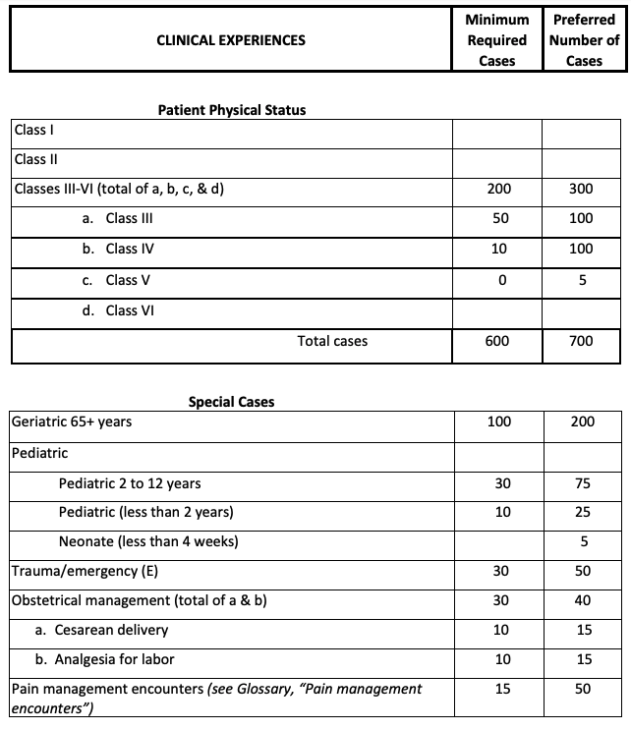
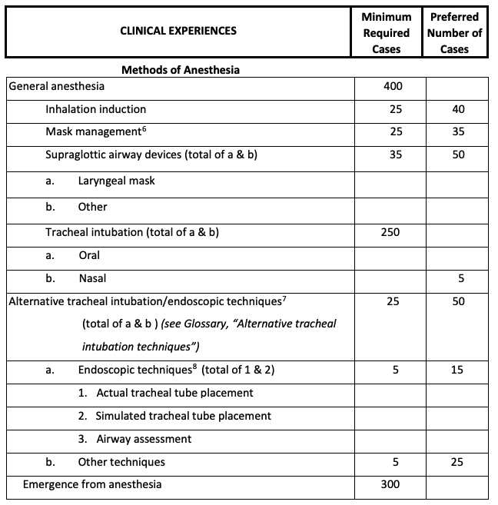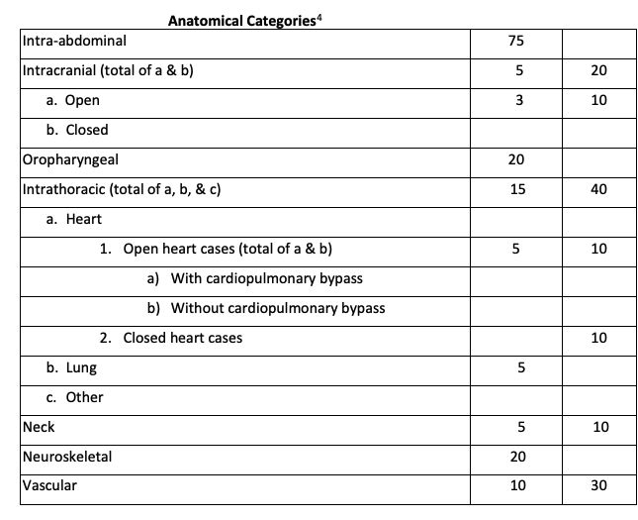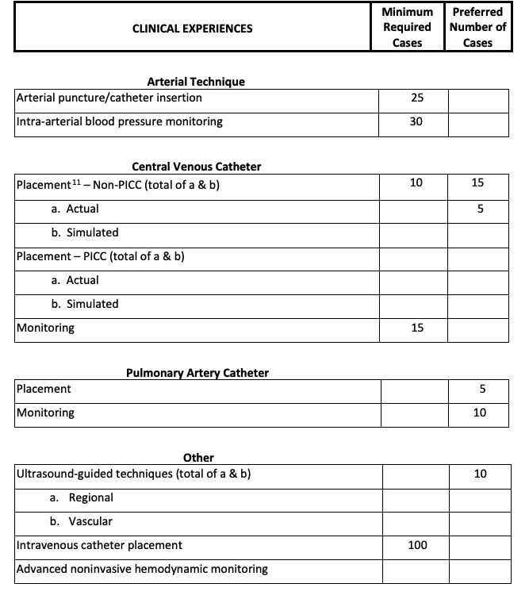

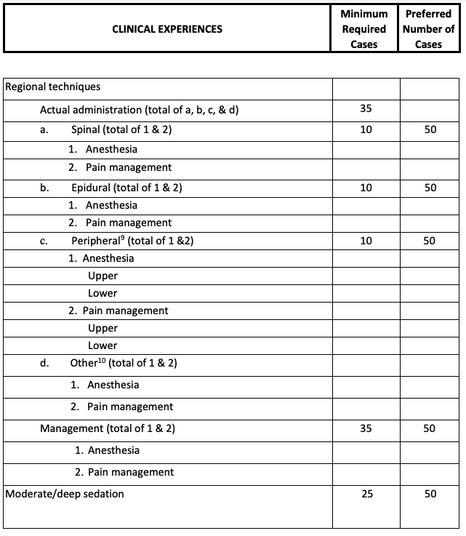

Appendix C
Nurse Anesthesia Program Curriculum Crosswalk

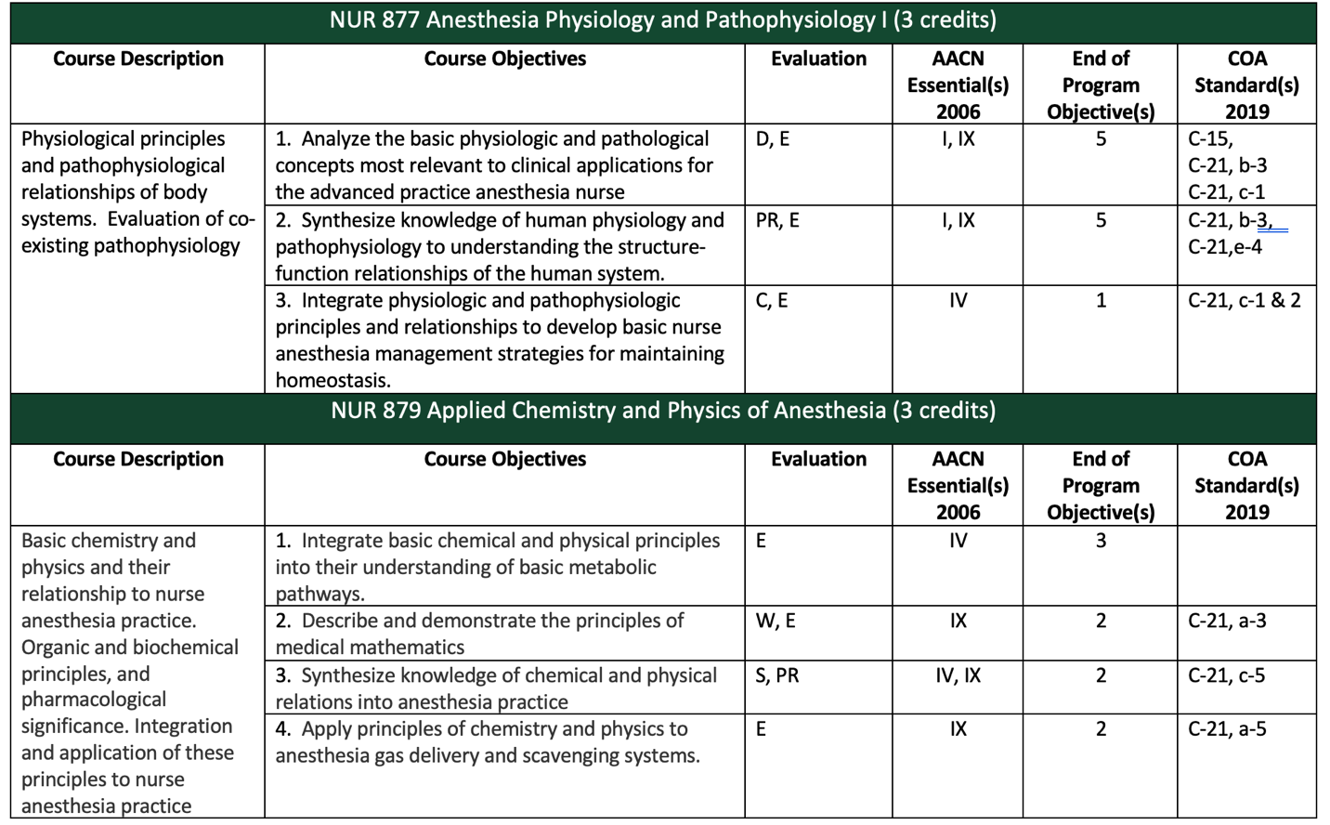
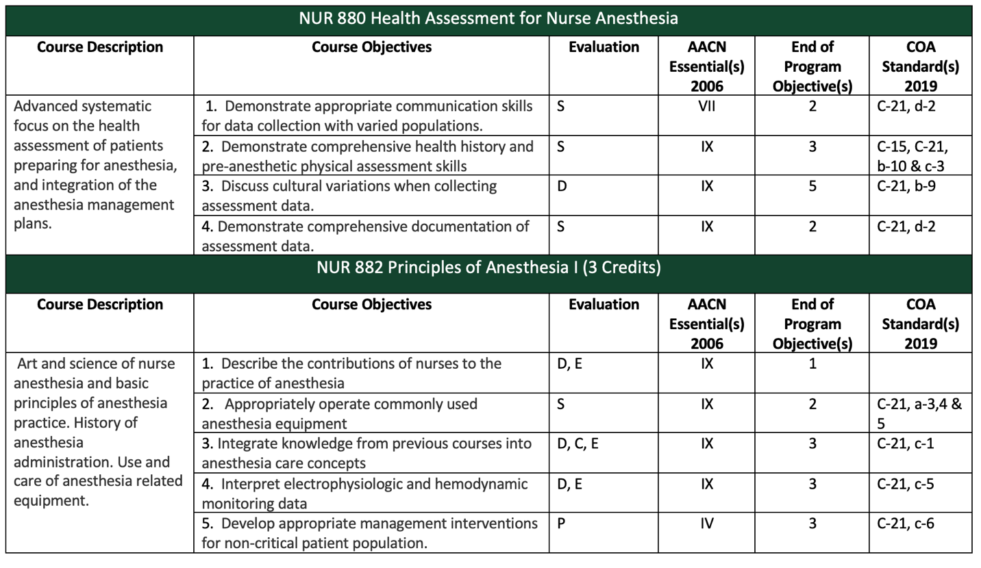

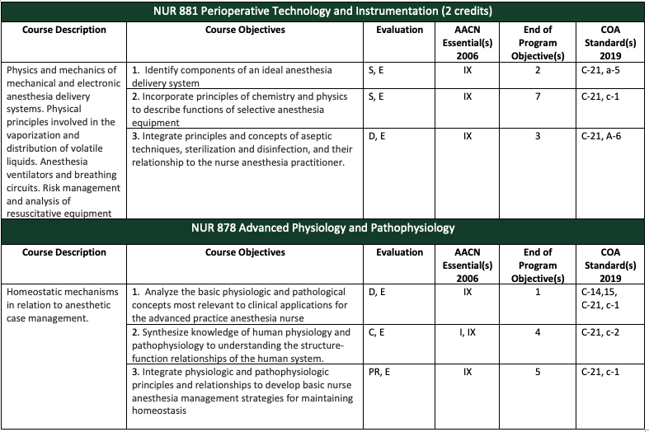
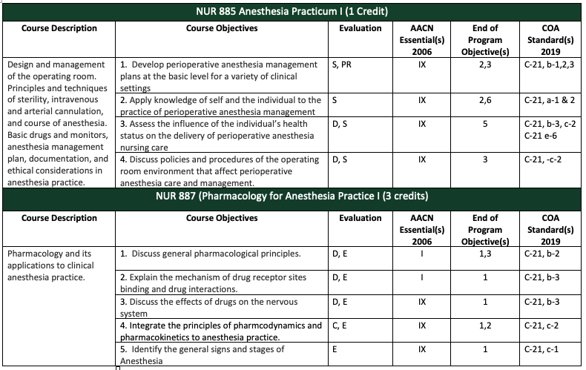
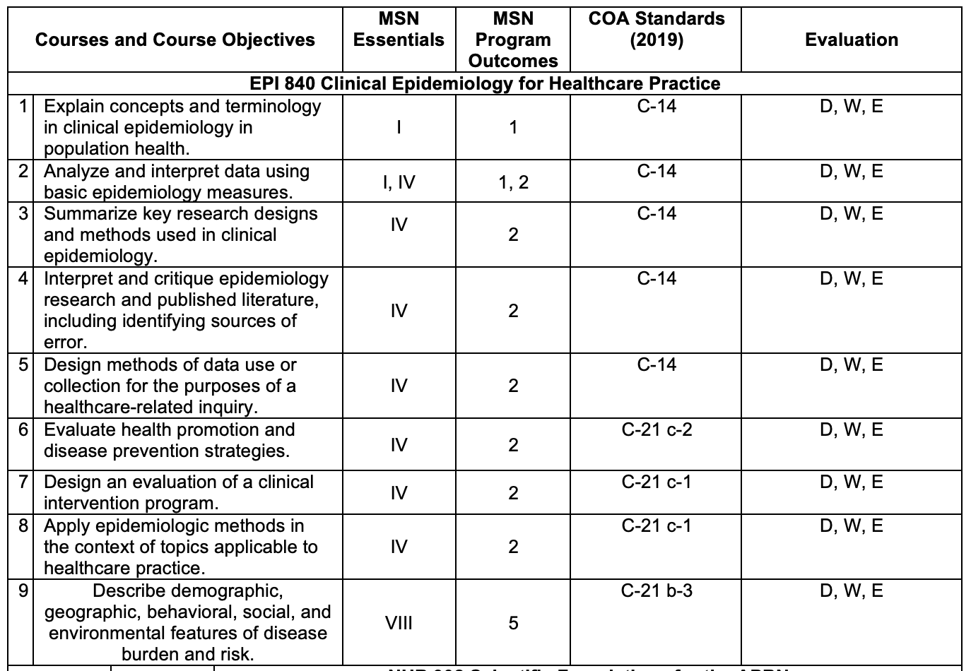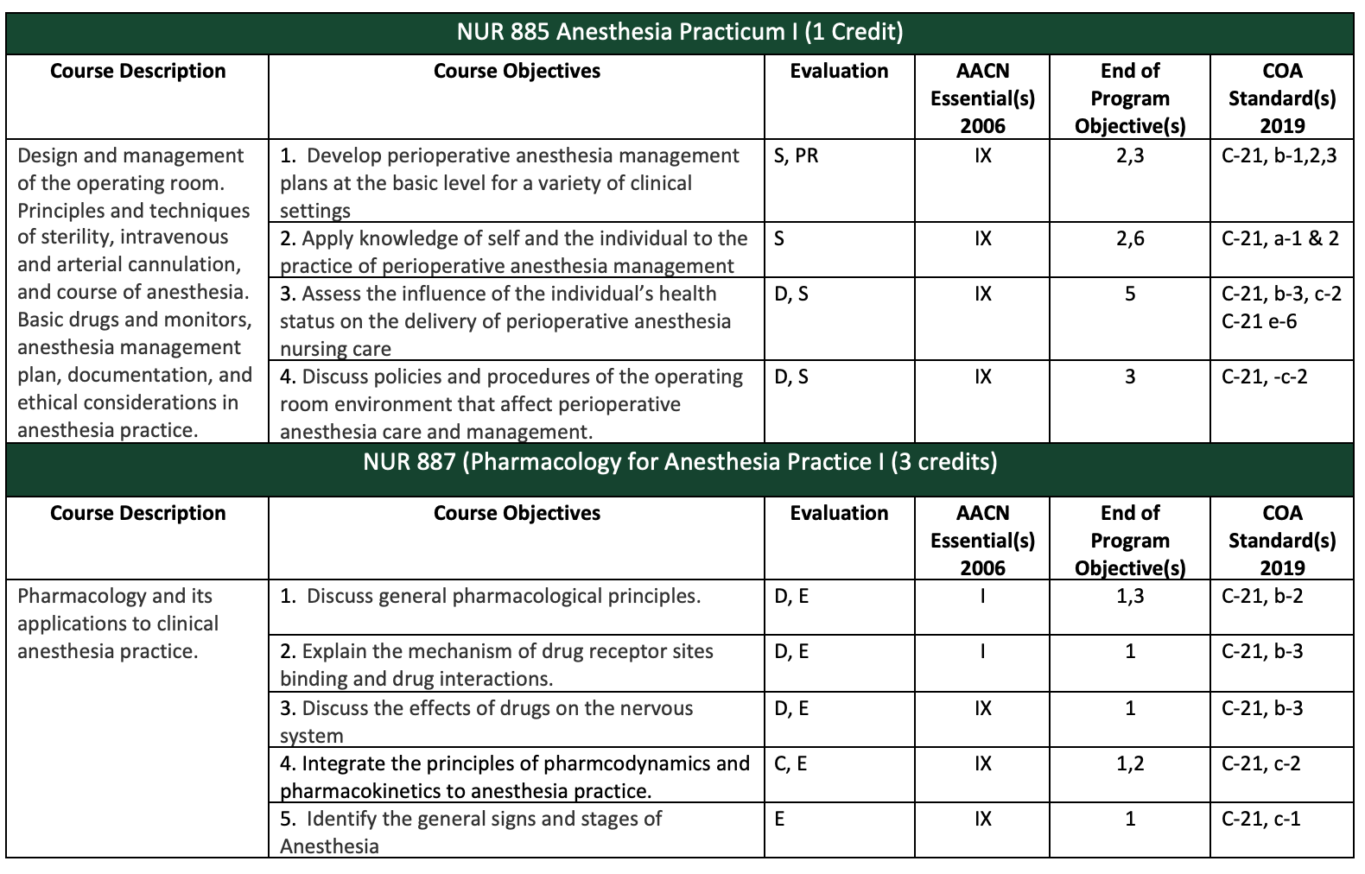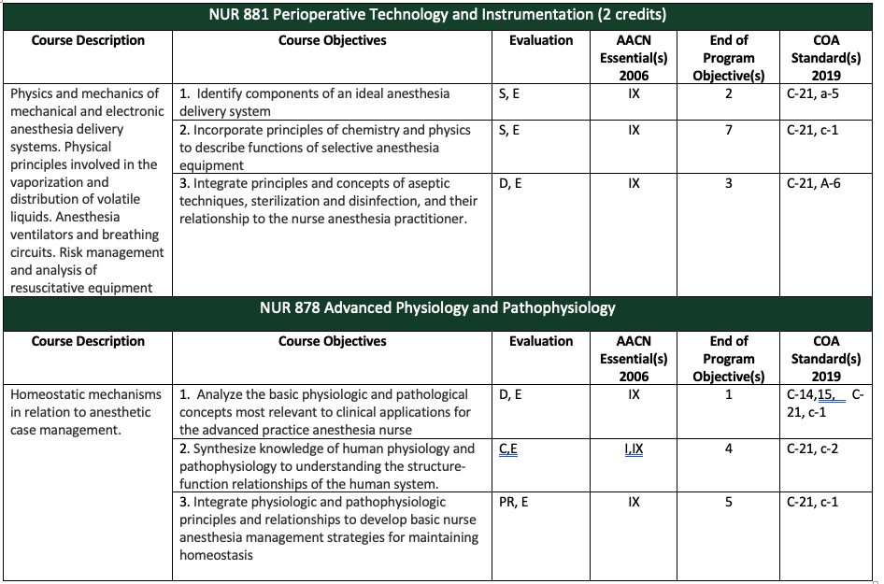
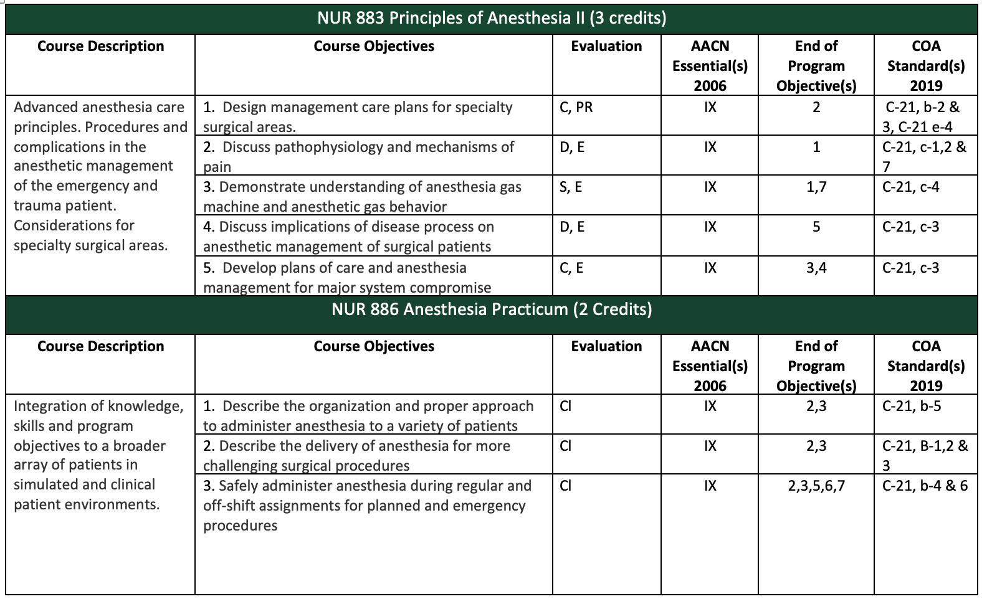

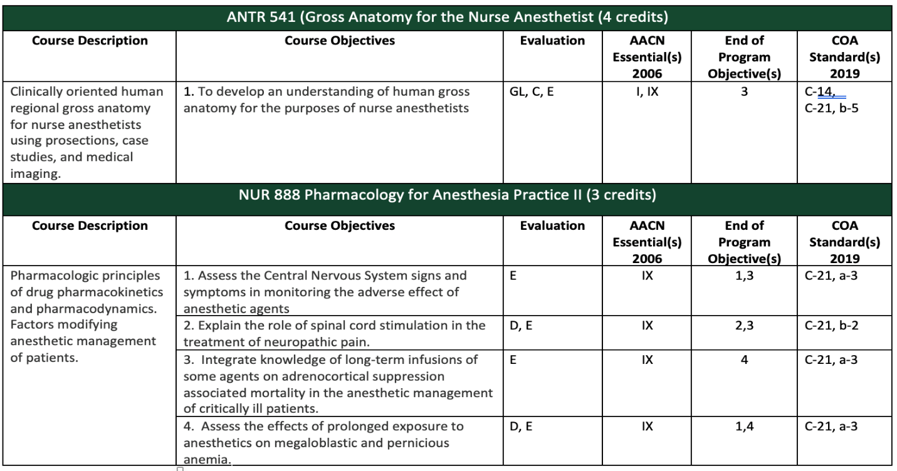
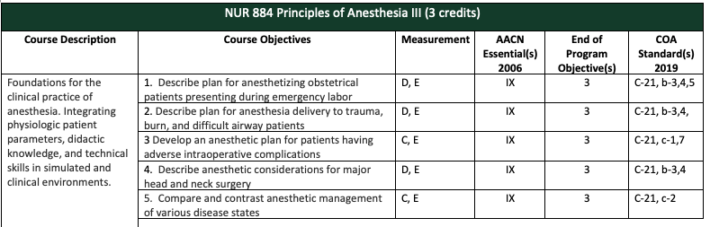
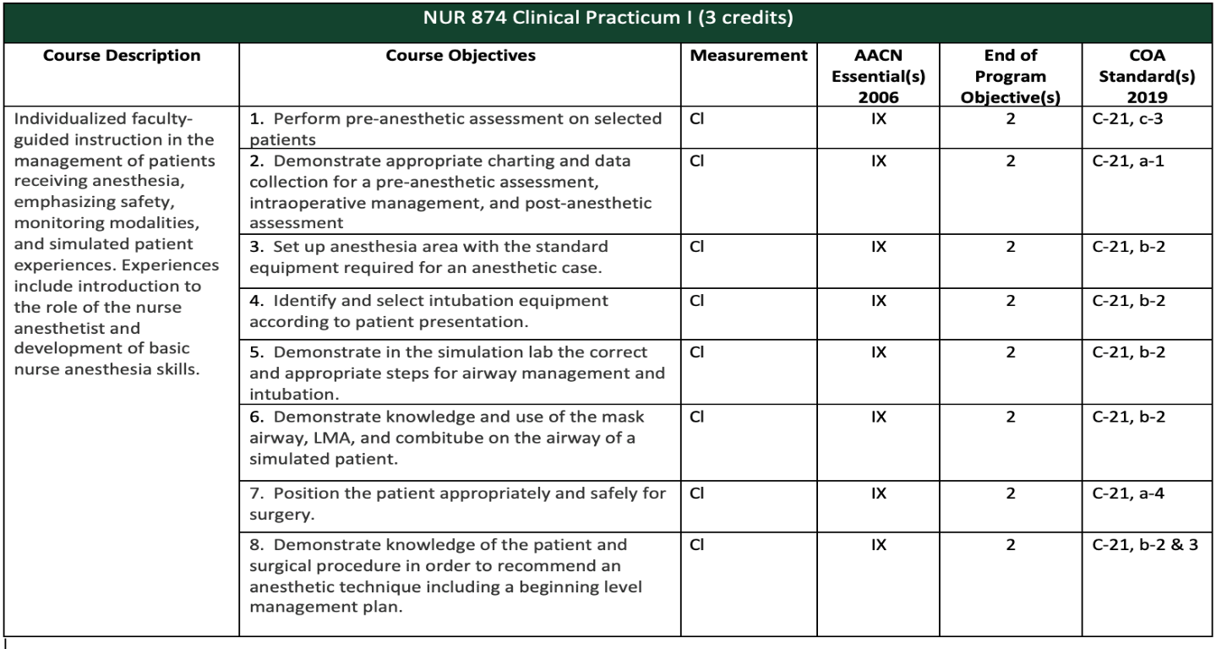
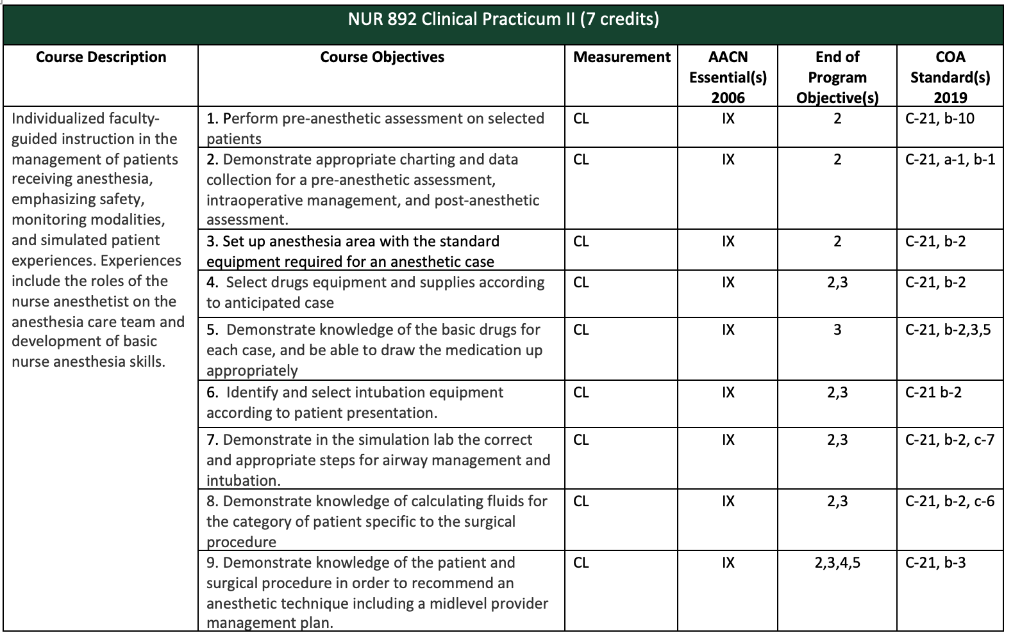
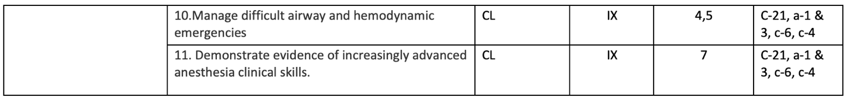
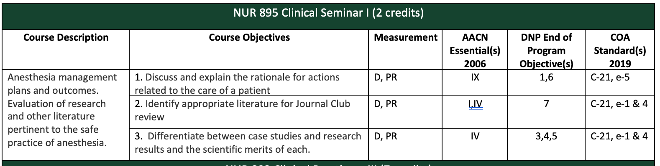
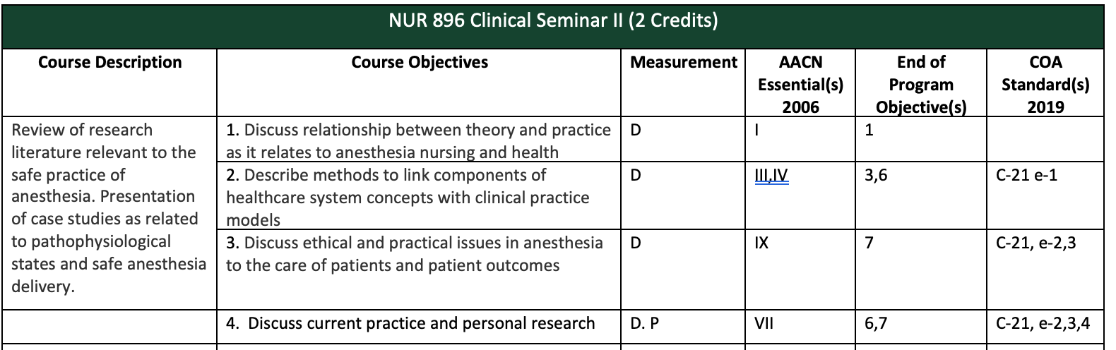
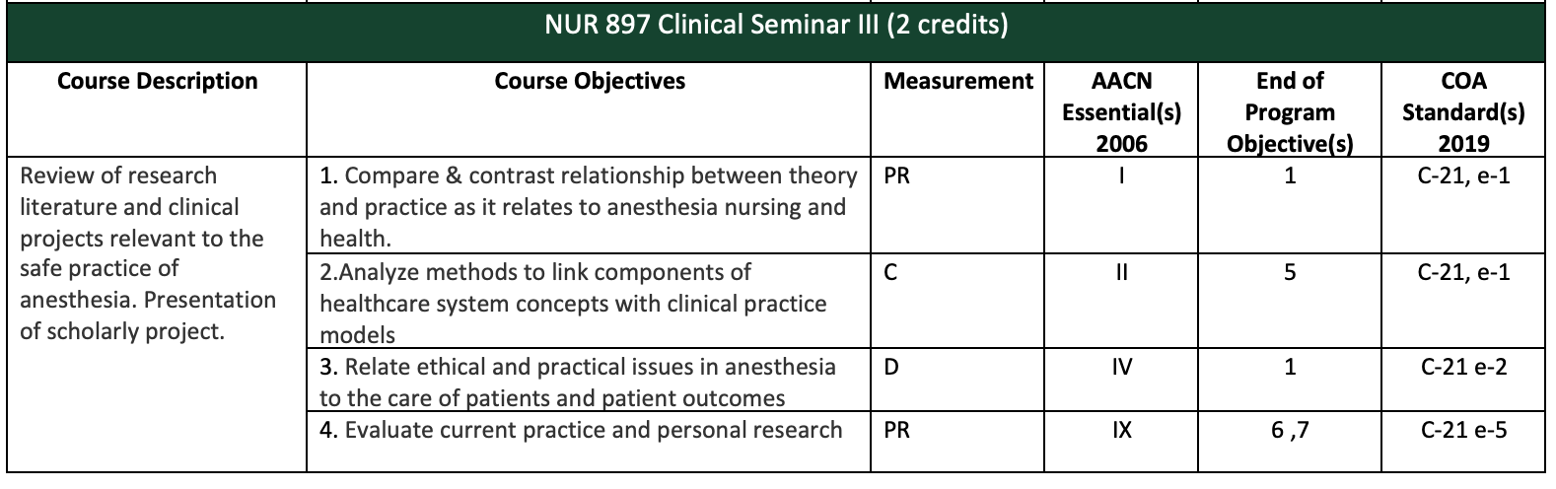
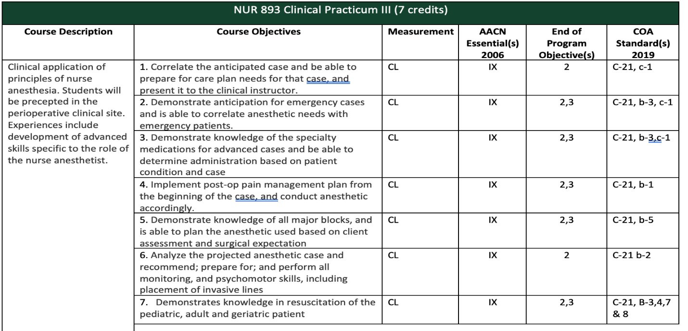
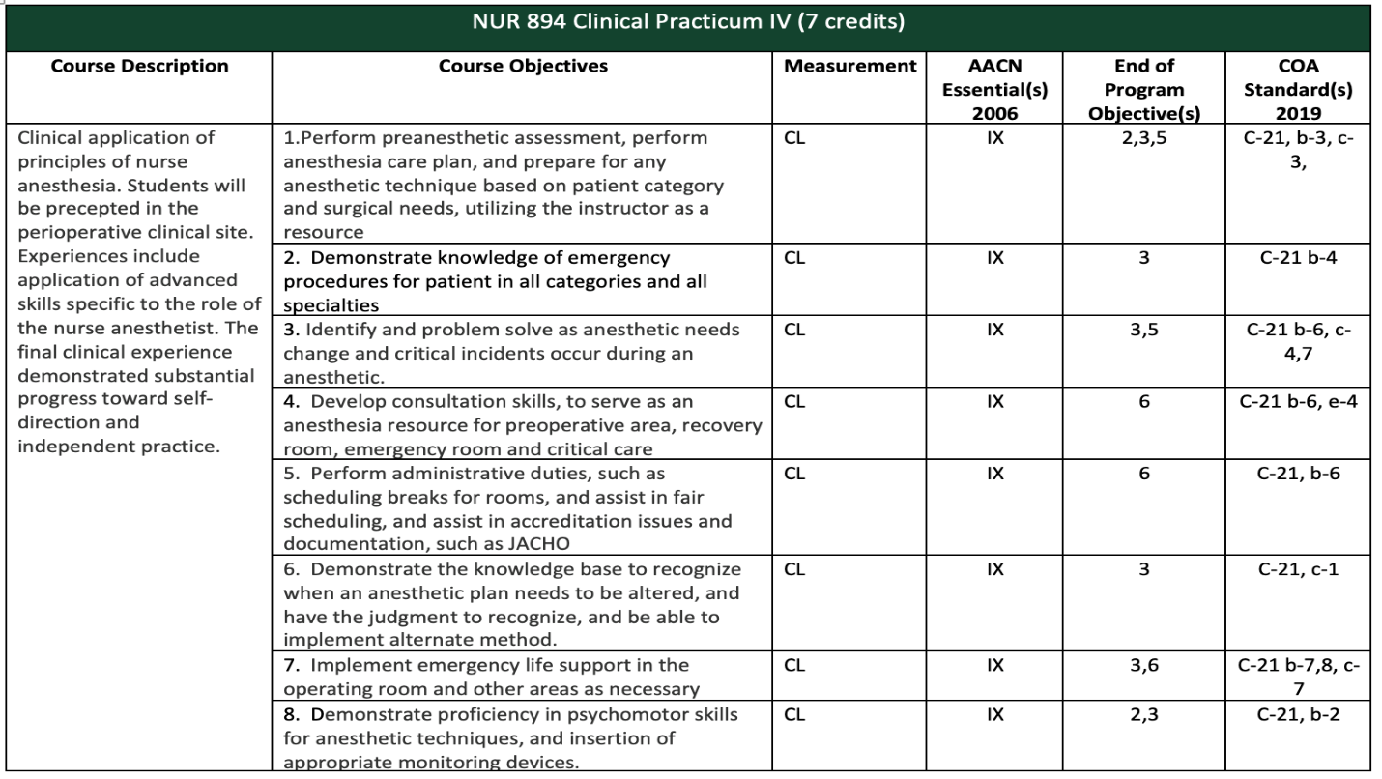
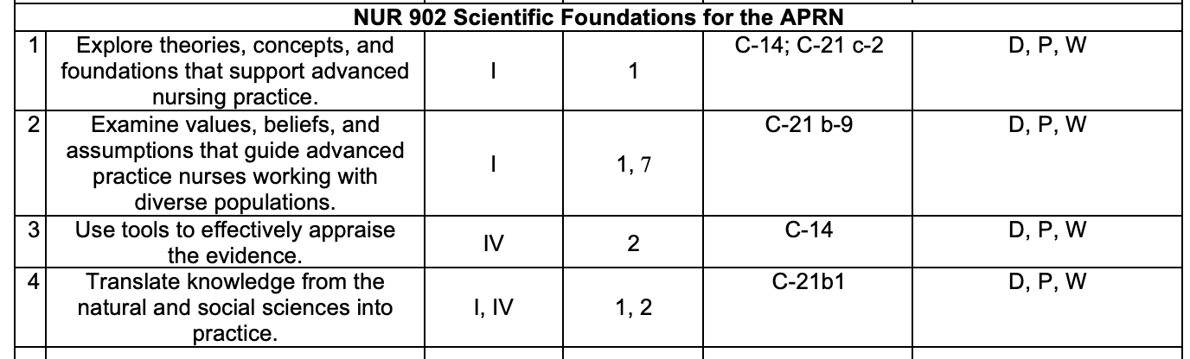
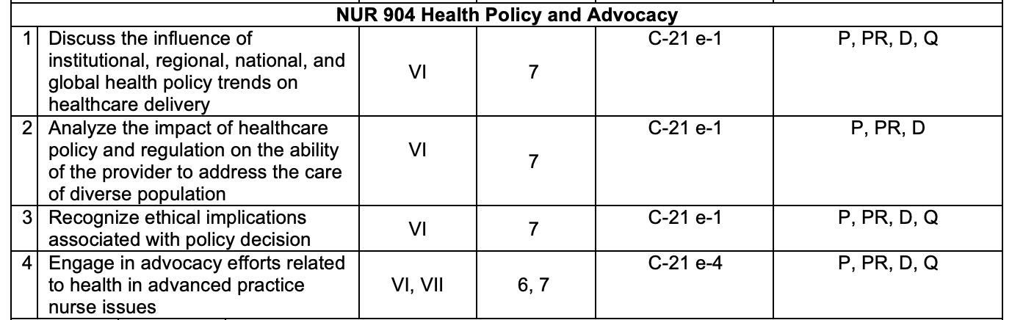
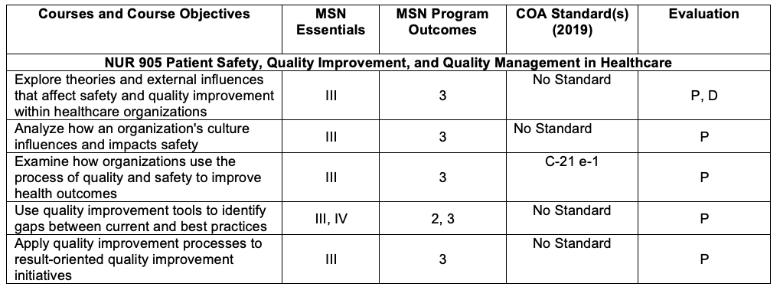

Appendix D
Nurse Anesthesia Program Trajectory

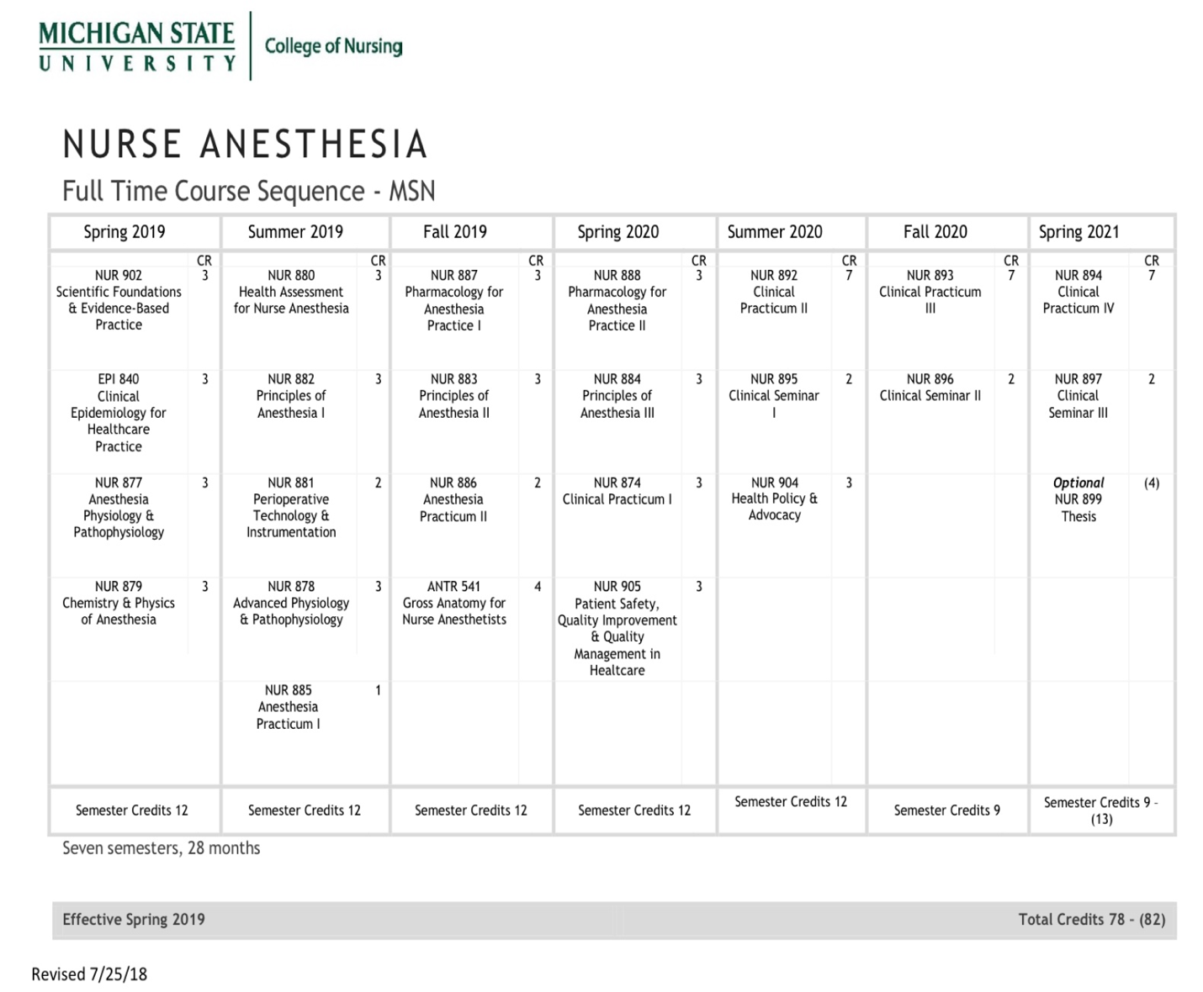

Appendix E
Communication Algorithm and Template

Note: Please allow 48-hours during regular weekdays for a response.
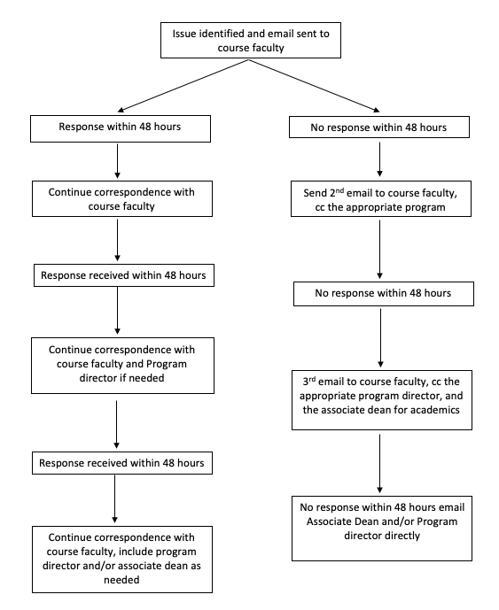
When communicating with faculty and peers it is expected that communication is professional and respectful. Below is an email example that may be modified if the communication is conducted verbally

Dr. ………
I am having issues in NUR###, specifically with ________________________,
I have tried (study groups, reviewing the readings/worksheets, tutoring, _________________), and I am still having issues/questions/concerns with_________________________________________________.
Or
I am wondering when we will receive feedback on_______________________
I am asking for (guidance, meeting, clarification, _______________________).
Thank you,
Your name

Appendix F
NAP End of Program Outcomes

At the end of the program, graduates will be able to:
- Evaluate phenomenon related to the practice of anesthesia by professional nurses to
facilitate strategies that impact and advance anesthesia-related health outcomes.
- Demonstrate care competencies that combine cognitive, affective, and
psychomotor skills to facilitate anesthesia practice as advance practice nurses.
- Apply the major critical thinking and analytic skills to effectively practice nurse
anesthesia in a cost-effective and accountable manner.
- Evaluate and utilize anesthesia-related research that enhance and advance the specialty
and disseminate outcomes to improve patient care.
- Integrate evidence in the delivery of care to diverse populations.
- Analyze leadership skills utilized in the evaluation of the quality of anesthesia care
provided throughout the community
- Integrate practice and education to expand the profession and practice of anesthesia
nursing.

Appendix G
Council on Accreditation of Nurse Anesthesia Programs
Master’s Graduate Standards
Council on Accreditation of Nurse Anesthesia Programs Graduate Standards:
Patient safety is demonstrated by the ability of the graduate to:
- Be vigilant in the delivery of patient care
- Refrain from engaging in extraneous activities that abandon or minimize vigilance while providing direct patient care
- Protect patients from iatrogenic complications
- Participate in the positioning of patients to prevent injury
- Conduct a comprehensive and appropriate equipment check
- Utilize standard precautions and appropriate infection control measures
Individualized perianesthetic management is demonstrated by the ability of the graduate to:
- Provide care throughout the perianesthetic continuum
- Use a variety of current anesthesia techniques, agents, adjunctive drugs, and equipment while providing anesthesia
- Administer general anesthesia to patients of all ages and physical conditions for a variety of surgical and medically related procedures
- Provide anesthesia services to all patients, including trauma and emergency cases
- Administer and manage a variety of regional anesthetics
- Function as a resource person for airway and ventilatory management of patients
- Possess current advanced cardiac life support (ACLS) recognition
- Possess current pediatric advanced life support (PALS) recognition
- Deliver culturally competent perianesthetic care throughout the anesthesia experience
- Perform a comprehensive history and physical assessment
Critical thinking is demonstrated by the graduate’s ability to:
- Apply theory to practice in decision-making and problem solving
- Provide nurse anesthesia care based on sound principles and research evidence
- Perform a preanesthetic assessment and formulate an anesthesia care plan for patients to whom they are assigned to administer anesthesia
- Identify and take appropriate action when confronted with anesthetic equipment-related malfunctions
- Interpret and utilize data obtained from noninvasive and invasive monitoring modalities
- Calculate, initiate, and manage fluid and blood component therapy
- Recognize and appropriately respond to anesthetic complications that occur during the perianesthetic period
- Pass the Council on Certification of Nurse Anesthetists’ (CCNA) certification examination in accordance with CCNA policies and procedures
Communication skills are demonstrated by the graduate’s ability to:
- Effectively communicate with all individuals influencing patient care
- Utilize appropriate verbal, nonverbal and written communication in the delivery of perianesthetic care

Professional role is demonstrated by the graduate’s ability to:
- Participate in activities that improve anesthesia care
- Function within appropriate legal requirements as a registered professional nurse, accepting responsibility and accountability for his or her practice
- Interact on a professional level with integrity
- Teach others
- Participate in continuing education activities to acquire new knowledge and improve his or her practice

Appendix H
MSU College of Nursing Responsibility Conduct of Research, Scholarship, and Creative Activities (RCRSA) Plan

